PERSONNEL REQUISITION FORM

JOB TITLE __CASHIER_______BRANCH __SM NORTH ANNEX BRANCH____

NO. OF PERSONNEL NEEDED: ___ONE (1) ONLY__DATE NEEDED: _MARCH 16, 2026_

JUSTIFICATION

Is this an increase to existing staff?

YES [ ] - Give reasons and comments NO [ / ] – This is a replacement for
___Lacking of Manpower during Operations
Name: NINIA MIRAS
__ ______________

Reason ( check one below)

[ ] End of Contract on:
[/ ] Resigned Effective: MARCH 16, 2026
[ ]Others:
REQUIREMENTS FOR THE POSITION

Experience____ SALES/ OPERATIONS__________________________________

Educational Attainment:____COLLEGE GRADUATE / HIGH SCHOOL GRADUATE_____________

Special Skills (required for the position) FOR:
___KNOWLEDGABLE IN SALES OPERATION_____ [ ] Probationary (Direct Hire)

________________________________________ [ / ] Contractual (Agency/DH)

________________________________________ [ ] Project (Agency/DH)

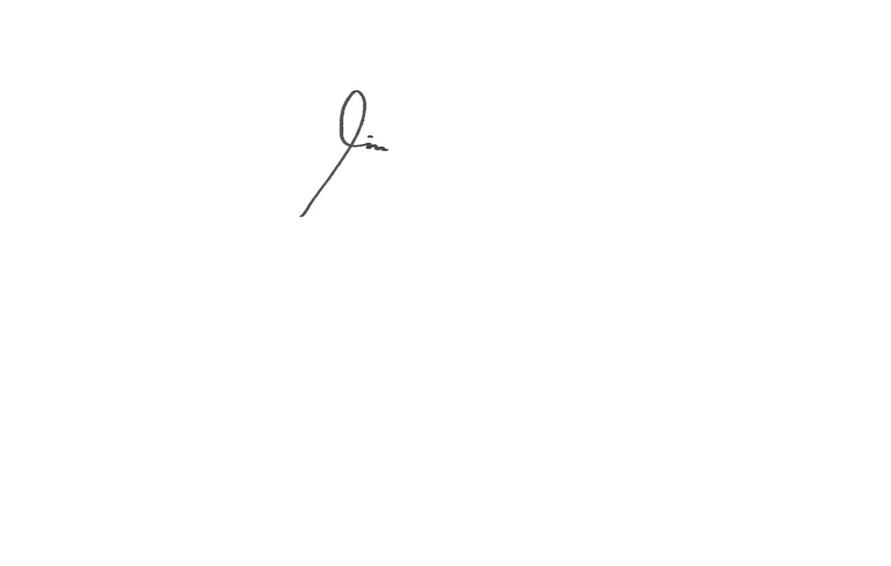

Prepared by: Reviewed by: Approved by: Noted by:

__GINA ARRIESGADO__ __KEVIN DIAZ__ __JESUS SOFIO GUEVARRA_____________
Branch Supervisor Cluster Manager Area Manager HRD

FOR HUMAN RESOURCES MGT. USE ONLY
Approved by:
__________________________
ALTHEA BUNACHITA
AGM

